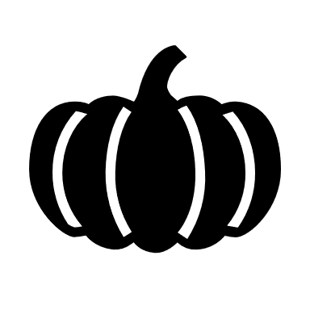
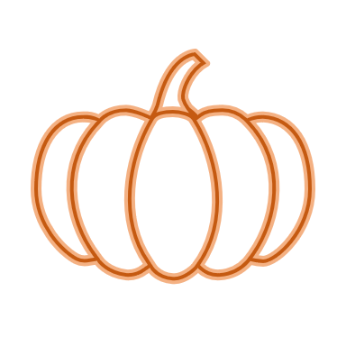
OCTOBER 2020 LUNCH
Sun | Mon | Tue | Wed | Thu | Fri | Sat
 |  |  |  | 1  Corn Dogs  Baked Beans  Celery/Carrot Sticks  Mixed Fruit Sauce | 2  Fish Nuggets  Potato Smiles  Cooked Carrots/Peas  Mandarin Oranges | 3
4 | 5  Hamburgers  French Fries  Baked Beans  Blueberries | 6  Chicken Strips  Seasoned Rice  Broccoli  Carrot/Celery Sticks  Pineapple Tidbits | 7  Turkey  Mashed Potatoes/Gravy  Steamed Broccoli  Oranges | 8  Pizza Burgers  Potato Puzzles  Cucumbers/Red Peppers  Apples | 9  Sub Sandwiches  Cucumbers/Cauliflower  Tomatoes/Pickles  Cheese Slices  Peach Sauce | 10
11 | 12  Chicken Patty  Romaine Lettuce  Tomatoes/Cucumbers  Grapes | 13  Chili  Grilled Cheese  Ped Peppers/Broccoli  Applesauce | 14  NO  SCHOOL | 15  NO  SCHOOL | 16  NO  SCHOOL | 17
18 | 19  B-B-Qs  Nacho Chips  Carrot/Celery Sticks  Cucumbers  Raisins | 20  Chicken Nuggets  Sweet Potato Fries  Green Beans  Strawberry Cups | 21  Pork Roast  Mashed Potatoes/Gravy  Steamed Cauliflower  Apples | 22  Hamburger Hotdish  Romaine Lettuce  Red Peppers/Tomatoes  Diced Pears | 23  Ham & Cheese Sandwich  Hash Brown Patty  Baked Beans  Diced Peaches | 24
25 | 26  NO  SCHOOL | 27  Spaghetti  Romaine Lettuce  Garlic Bread  Tomatoes  Blueberries | 28  Diced Chicken Gravy  Mashed Potatoes  Green Beans  Biscuits  Mixed Fruit Sauce | 29  Pizza Choice  Carrot Sticks  Broccoli/Cucumbers  Grapes | 30  Orange Chicken  Seasoned Rice  Country Vegetables  Mixed Fruit Sauce | 31
Happy Fall!!!

